We hope to educate the public regarding the proposal to increase the fee for use of the Charlestown Transfer Station.

Below is some information regarding what it costs to operate the transfer station, and what those fees cover cost-wise.
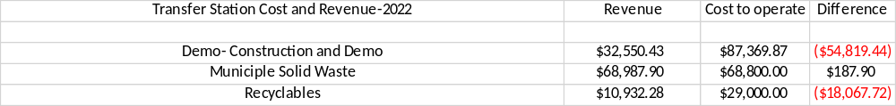

The average household discards 1 kitchen sized-bag (30 gallon) of trash per week, over 1500 pounds of household trash per year. The average cost in other towns in the state of NH is $2.50 per bag, which equates to $130.00 per year. We are still far below that price at $75 per year, almost half the cost.

Below is what it costs the town to discard items that are recycled:

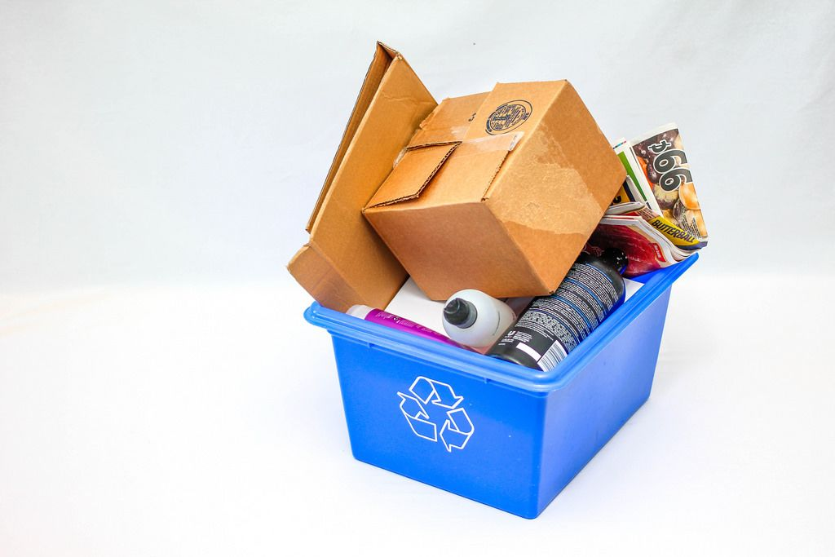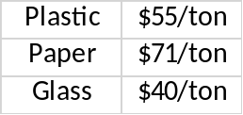

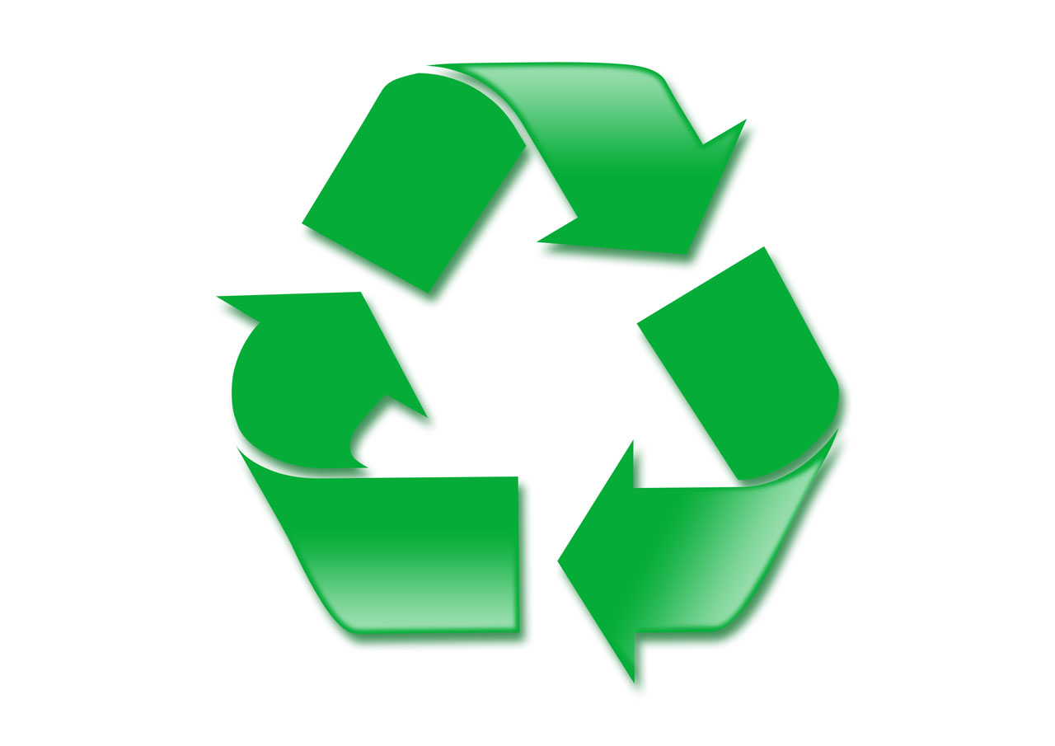We appreciate everyone’s efforts to keep Charlestown green by recycling, and we encourage everyone to continue their efforts!

Thank you for your attention to this matter.

