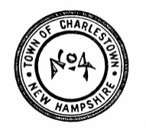
BOSTON POST CANE
With the recent passing of Elizabeth O’Brien Ward at the age of 102, the Charlestown Selectboard is seeking potential recipients of the Town’s Boston Post Cane. The Cane is held by the oldest registered voter residing in Charlestown. To be eligible one must have been a resident of Charlestown for at least 25 years. The Cane must remain within the confines of the Town at all times. Anyone knowing of a potentially eligible recipient is asked to contact Jessica Dennis in the Selectboard Office at (603) 826-5368, or via email at jessica@charlestown-nh.gov providing the name, address, phone number and date of birth of the potential recipient. Further information about the Cane including its history and past holders may be obtained from the Selectboard Office at 233 Main Street, PO Box 385, Charlestown, NH 03603.

