In a continuing effort to
reduce waste, we also
offer the
Re-Use Center
Clean, Usable Clothing
Books
&
Some Household Items
Other items MUST be disposed of in the proper location.
Attendant may refuse items
The Re-Use Center is the only area of the transfer station
from which items may be removed.

"Dump Picking"
is strictly prohibited!

Thank you for keeping Charlestown green by recycling!

TRANSFER STATION STICKERS ARE PURCHASED AT THE TOWN OFFICE.
TOWN OFFICE HOURS
MONDAY & WEDNESDAY
7 AM – 4 PM
TUESDAY & THURSDAY
8 AM – 4 PM
FRIDAY
7 AM – 12 PM

LIMIT 2 STICKERS PER HOUSEHOLD
$75.00 – FIRST STICKER
$20.00 – SECOND STICKER
PLEASE BRING VEHICLE REGISTRATION WITH YOU AT TIME OF PURCHASE.

TRANSFER STAION STICKER MUST BE ON THE PASSENGER SIDE FRONT
WINDOW TO ACCESS FACILITY

CHARLESTOWN
TRANSFER STATION
FOR USE BY CHARLESTOWN RESIDENTS ONLY

USER GUIDE

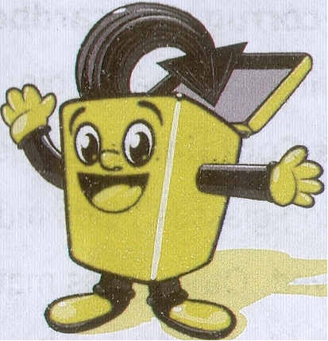

HOURS OF OPERATION
TUESDAY: 1 PM – 4:25 PM
WEDNESDAY: 1 PM – 5:55 PM
FRIDAY: 1 PM – 4:25 PM
SATURDAY: 8 AM – 4:25 PM

QUESTIONS?
CALL 603-826-3201 OR
603-826-4421
MANDATORY RECYCLING
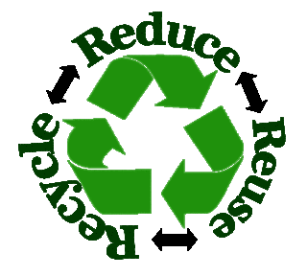
All mandatory recycling items must be placed in the designated areas. Materials all need to be clean, dry and free of other materials.

- Corrugated Cardboard – clean & flattened
- Non-corrugated Cardboard – flattened & placed in mixed paper bin
- Glass Containers (bottles, jars, drinking glasses) Lids must be removed. Other glass materials may be recycled and must be placed into designated bins.
- Computers and Electronics and Televisions - There is a fee for recycling these items. See Disposal Fees list.
- Mixed Paper – newspaper, magazines, shredded paper, cereal boxes, food boxes (pasta, snack, cakes, etc), egg cartons, paper towel and toilet paper rolls, soda and beer boxes –please flatten all boxes
- Aluminum Cans
- Tin Cans – cleaned
- Plastics – Soda Bottles, Milk Jugs, Detergent Bottles, etc.
No Flower Pots, Totes, Toys, Food Containers or Bulky Items
The mandatory recycling policy shall be strictly enforced as follows:

- First offense shall result in a $25.00 fine.
- Second offense in one (1) calendar year shall result in a $50.00 fine.
- Third offense in one (1) calendar year shall result in the loss of Transfer Stations privileges for a period of one (1) month and a
$75.00 fine

Voluntary Recycling

Yard and Garden Waste, Car Batteries, Motor Oil (in 1-gallon containers)

Other Services

- Scale Fee - $10.00
- Burn Pit –
BRUSH & PALLETS ONLY
- Composting - Leaves, pine garden waste only. Plastic bags must be removed. Finished needles, grass clippings and compost available for purchase.

Full Bucket - $10.00 3/4 Bucket - $7.50
1/2 Bucket - $5.00 1/4 Bucket - $2.50

- Hazardous Household Waste Charlestown Transfer Station DOES NOT ACCEPT HAZARDOUS WASTES. For disposal, contact the City of Keene at 352-5739 or the Upper Valley Lake Sunapee Regional Planning Commission at 448-1680 for other options.

Disposal Fees
- Demo under 20 pounds - $2.00
- Construction/Demolition Debris (Painted/treated wood, sheetrock, etc) - $0. 07 per pound
- Mattresses - $30.00 any size
- Furniture/Bulk Plastic items etc - $0.07 per pound
- Refrigerators, Freezers, Dehumidifiers Air Conditioners, - $15.00 each
- Car/Light Truck Tires w/rim - $4.00 each, no rim with debris $5.25 each
- Tires 19” – 22” - $15.50 each, no rim with debris $17.50
- Heavy Truck & Tractor Tires - $50.00
- Fluorescent Light Tubes - $0.25/ft
- Fluorescent Bulbs (CFL) - $1.00
- Television(s) - $0.25 a pound
- Torch Tanks - $1.00 each
- Propane Tanks – 20lbs-100lbs
***See Attendant
- Helium Tanks - $5.00 each
- Computers (CPU, monitor, keyboard) - $5.00 per piece or $10.00 complete set
- Misc. Electronics - $2.00
- Microwave Ovens - $10.00 each

PROPER DISPOSAL OF THE ABOVE ITEMS IS REQUIRED

