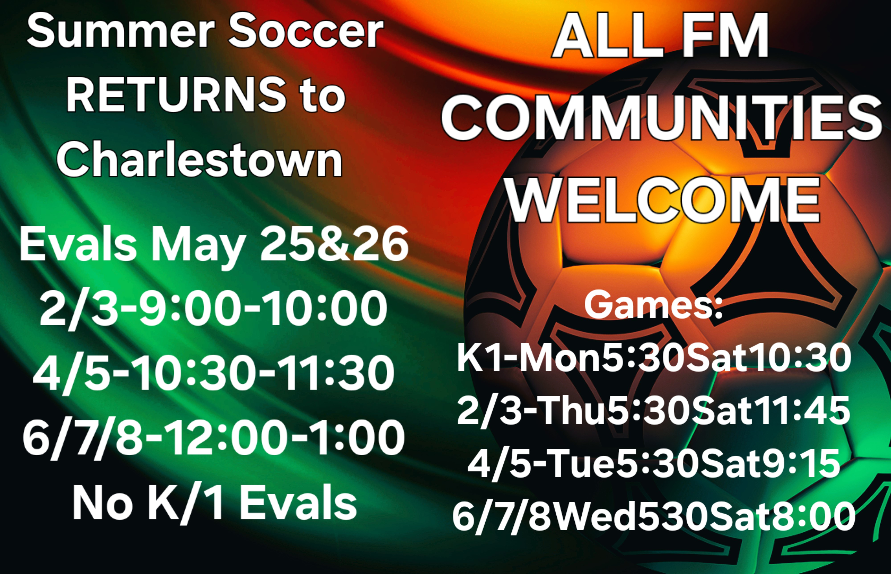
CHARLESTOWN
RECREATION
SUMMER SOCCER

ALL AGE BRACKETS ARE DESIGNED AROUND WHAT GRADE YOUR ATHLETE WILL BE ENTERING IN THE UPCOMING FALL SEASON. K/1 2/3 4/5 6/7/8

FEE: $25.00 PER CHILD
SIGN-UP FORMS & PAYMENT ARE REQUIRED PRIOR TO PARTICIPATION: Forms can be dropped off at the Charlestown Town Clerks office, Recreation office, or in person by appointment. LATE REGISTRATIONS WILL BE CONSIDERED but we would appreciate prompt notification. Your athlete will then be placed on a team following the evaluation and draft.
REGISTRATION DEADLINE: (FIRM) June 3, 4:00 P.M.
(FOR QUESTIONS CALL/TEXT (603-477-9455 OR EMAIL coachjwest22@gmail.com)

DIVISION: K1 2/3 4/5 6/7/8

Name__________________________________D.O.B.______________Age_______Grade________

SHIRT SIZE- YOUTH: S M L XL ADULT: S M L XL

ADDRESS:_________________________________________________________________________________________

EMAIL_______________________________________________________ PHONE___________________________

GUARDIAN NAME____________________________________________

I WOULD LIKE TO

COACH/OFFICIATE: __________________________________________ SHIRT SIZE________________

SIGNATURE___________________________________________________ DATE______________________________

GOOD SPORTSMANSHIP WILL BE SHOWN BY ALL PLAYERS, PARENTS, SPECTATORS AND OFFICIALS. BY SIGNING THIS DOCUMENT I AGREE TO UPHOLD, ENCOURAGE, AND ENFORCE GOOD SPORTSMANSHIP

